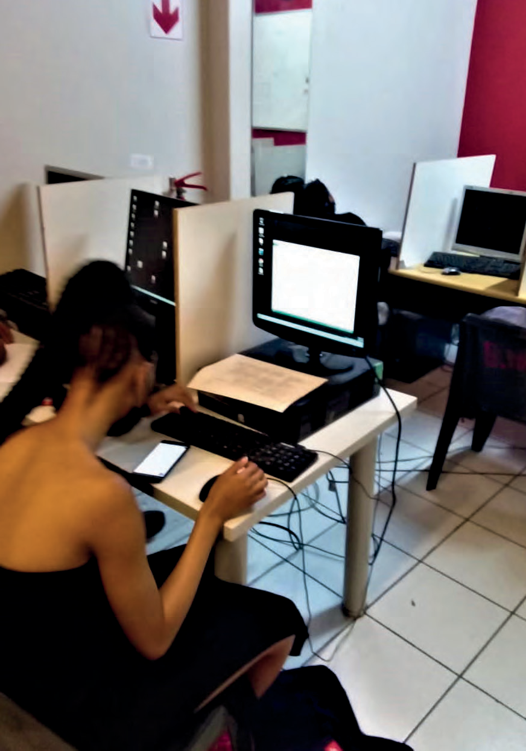



Gigabytesmind Technologies

Company Profile




Profile Contents

About the company 2
Vision. 2
Mission. 2
Objectives 3
Creating new values 3
Breaking Frontiers 3
Our People 3
Our Corporate Responsibility 3
Broad Based Black Economic Empowerment. 4
Organisational Structure 4
About the owner 5
Executive Team. 6
Our services 7
Business branding 13
References 14
2
About the Company

Gigabytesmind Technologies is fully owned by a young black woman, Ms Johanna Mokgaedsi Moabelo. The company was registered in 2018 with the CIPC (Registration number: 2018/237287/07. Gigabytemind technologies PTY LTD offers remote or onsite services that manage organizations technological assets, computer training as well as business branding. Managing IT also involves the creation, optimization, and accessibility aspects of a company. With seeing a need of computer literacy amoung the youth, we saw it fit to offer computer training as one of our scope of services.

There is a growing trend of individuals ventering into entreprenuership, which makes business branding more and more required by these folk. We advertise as much as possible to ensure we spread the message of why business branding and marketing is important. Gigabytes Technologies (Pty)Ltd offers business branding and business marketing as a service that we consider it to be growing in importance.

The goal is to help businesses manages their IT goals and keep running a tip-toe shape. We are growing everyday hence our main objective is to reach within both and international market within the IT sector. We are not restricted to anything regarding information technology, we offer services from Computer Architecture, Networking up to Software development. We cater small to large scales of projects for both private and government sectors.

We are a team of computer specialists, young, flexible and innovative.

We strive on ensuring our service delivery is at optimal level. Absolute excellence being our tag line, our commitment is vital to our business growth by providing meaningful services to the public.

Our work our Pride.

VISION

Our vision revolves around ensuring the running of the company practices the below:
- Professionalism
- Good work ethic
- Punctuality
- Flexibility- supports several projects simultaneously
- Quality service

MISSION

To deliver the best product and service in the most cost efficient way possible to any client and to build healthy business relations in the industry that knows us by reputation. We pride ourselves on our professional approach and high level of service. Our attention to detail and close supervision ensures that every job undertaken is performed to the highest standard and we endeavour to exceed the expectations of our clients every step of the way.



OBJECTIVES

Our objectives include:

- Be a reputable service provider by providing quality service.
- Successfully train the youth on computer literacy.
- Provide quality business brands.
- Provide quality IT solutions.
- Inspire businesses.
- Become a change agent for female business owners.

CREATING NEW VALUES
We work a broad range of clients, our clients and partners have close relation to some of up and coming companies.
We highly aim to get aspiring entreprenuers more eager
to enter the business world. We understand that jobs won’t create themselves more and more businesses should be created. Using our combined experience, technical expertise and local knowledge, we’re able to deliver projects and services that contribute to the community, our economy and future generations.

BREAING FRONTIERS
Offering IT solutions, training programmes, graphic designing, motion graphics and web development are becoming a niche and increasingly important. Building a brand is not the mere designing of a business logo and marketing but revolves around building hype and recognition of a business. Effective communication of what a business stands for, is our bottom line goal. We are solely motivatived to finding new ways to get a business out there into the world.

OUR PEOPLE
We are a company that prides itself on its ‘family’ culture and we seek out high-calibre people. We are a company that has, at
its core, a team philosophy that is clearly apparent each and every day – there is a real sense of being there for one another. We believe in nurturing the skills of our team membersand providing growing levels of responsibility.

OUR CORPORRATE RESPONSIBILITY

GigabytesMind Technologies (Pty)Ltd recognises its obligations to act responsibly, ethically and with integrity in all its dealings, its staff, customers and the environment.

3

BROAD BASED BLACK ECONOMIC EMPOWERMENT

The company conforms to the BBB-EE Act through compilance with the seven key elements of BBB-EE namely:

  - Ownership
  - Management Control
  - Employment Equity
  - Skills Development
  - Preferential Procurement
  - Enterprise Develppment
  - Socio-Economic Development

MBS is 100% black-owned and managed by
a dynamic and multi-skilled staff complement consisting of highly qualified and experienced young men and women.

OWNERSHIP | 100% Black Owned
GENDER OWNERSHIP | 100% Female owned
STAFF | 100% Black
STAFF GENDER | 40% Female & 60% Male

ORGANISATIONAL STRUCTURE
Gigabytes Technologies (Pty)Ltd prides itself on its ’family’ culture and we seek out and attract high-calibre people.

General Manager Team Leaders Staff










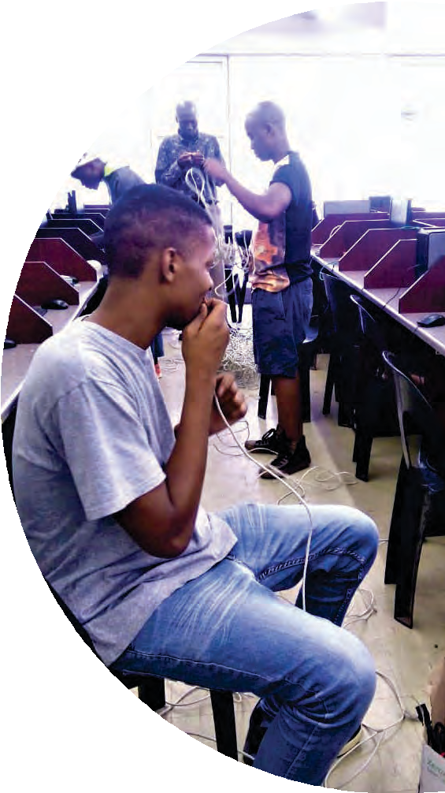
Project Manager Purchasing Manager Office Manager
IT Team lead Training Team Lead Graphics Team Lead
IT Team Training Team Design Team Printing Team
General Workers 4



About the Owner

Johanna Mokgaedsi Moabelo is the founder and director of Gigabytesmind Technologies
(Pty) Ltd. She comes from a place called Hammanskraal far North of Pretoria. She studied Information Technology and worked with

registered as an Assessor and a Moderator with mict seta. Her love and passion for information Technology drove her to register a company in 2018 to date.

She is hardworking, motivated and assertive. Her goal is to create and jobs and visual learning across the all borders.

She has always had a passion for business and providing a service that has true value to the public at large. Seeing that she
is highly inclined to technicalities of computers, training others and

incorporate GigabytesMind Technologies (Pty)Ltd. She aims to continuosly grow it and ensure its client base is increased.

MESSAGE FROM THE OWNER

“I believe that every dream dreamt as purpose, dreams are a glimps into the future but only if they are
business owners and aspiring entreprenuers should put in the work to ensure their passions come into reality.
an ordinary life.”

- Johanna Mokgaedsi Moabelo
Owner of GigabytesMind Technologies (Pty)Ltd

5



















Executive Team 6
ity
of

Miss. JM Moabelo
Founding & Managing Director
Johanna Mokgaedsi Moabelo founder and of Gigabytesmind Technologies (Pty)Ltd since 2018 to date.
Educational Background:
- Assessor and Moderator with Mict SETA
Truly passionate about information technologies and its divisions.

Mr. L Maluleka
Head of Information Technology

Lucky Maluleke have vast experience in technical support and training.
Education Background:

- National Diploma in Information Technology
- Assessor and Moderator with Mict SETA

Has diverse lecturering skills and driven by learner success.

Mr. GG Setwaba
Head of Design

Top performing Matriculant at Hans Kekana High School.
Obtained BCom Accounting from the University from the Univers ty of Johannesburg. Awarded Top Performer amonst others at the University of
ing quali cation.

Customer Service, Graphic Design, DTP Editing, Business Administration. Has great passion for business presentation and marketing.

Through dedication and commitment shown by te executive team at Gigabytesmind Technologies (Pty)Ltd, we have grown from strenght to strenght. We are builing a company to withstand the test of time while deliverying exceptional quality services.


7
Our services

Our approach is to lean, scalable solution with a proactive approach to problem solving that keeps our client systems operating at the peak performance at a 99% rate.
7 days a week to accept and address inbound support issues. We also manage all software platform
remote support.

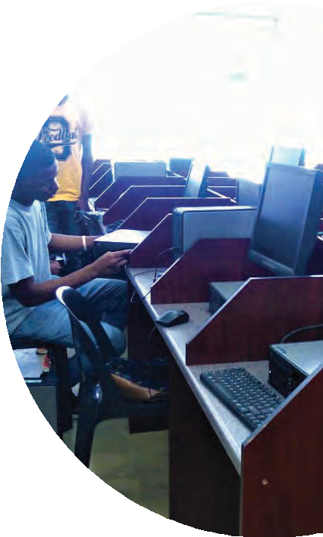
Our services include:

INFORMATION TECHNOLOGY DIVISION
- We build Computer Labs
- Website Development
- Software Development
- Mobile Apps
- Whatsapp Integration
- Cloud Management
- Managed Services
- Network Security
- Consulting
- Key Services
- User management
- Security monitoring & response
- Software License management
- 24/7 system monitoring
- Software Deployment &updates Hardware inventory

TRAINING DIVISION
- End-User training
- Hardware installation
- Full time onsite support
- End-user computing level3
- System support level4
- Technical support level 4
- Computer Practice N4-N6
- Information Processing N4-N6

Gigabytesmind technologies expanded in the educational entity, we are also asmaller learning institution that seek and prepare critical thinking college bound, and community servants to impact their world

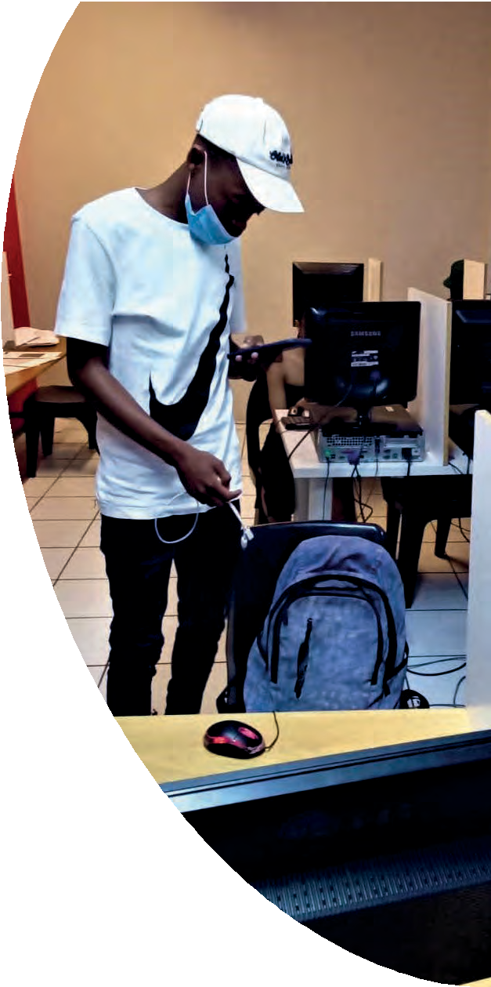
GRAPHIC DESIGN/ BUSINESS BRANDING DIVISION
8
- Business Logo Design
- Clothing Brand Printing Design
- Brochures
- Flyers
- Pamphlets
- Publications
- Annual Reports
- PowerPoint Presentations
- Invitations (Social Media Poster & Printable)
- Invitations (Video)
- Social Media Advertising Poster
- Packaging
- Menus
- Posters
- Newsletters
- Business Cards
- Letterheads
- Email Signatures
- Banner Design
- Chromodeck Signage Design
- Calendars
- Car Magnet Design
- Social Media Page Cover Photo
- Magazine
- Album Cover
- Ticket Design

Business Branding Solution

Package 1 | Package 2 | Package 3 | Package 4 | Package 5 | Package 6
- B/Logo  - Invoice | - B/Logo  - Invoice  - B/Card | - B/Logo  - Invoice  - B/Card  - Letterhead | - B/Logo  - Invoice  - B/Card  - Letterhead  - E/Signature | - B/Logo  - Invoice  - B/Card  - Letterhead  - E/Signature  - Poster | - B/Logo  - Invoice  - B/Card  - Letterhead  - E/Signature  - Poster  - Video
Stationery Package

Package 1 | Package 2 | Package 3
Company Branded Ballpoints Company Lanyards | Company Branded Ballpoints Company Lanyards Company USB’s | Company Branded Ballpoints Company Lanyards Company USB’s  Company Envelopes


9
NETWORK AND SYSTEMS SERVICES
LAN and WAN Designing

Keeping your business running smoothly requires building and maintaining a robust, highly available network. Gigabytesmind Technologies (Pty)Ltd

results for your business.From wireless networking with VoIP, to multi-location WAN intranets with mobile-ready remote access, to cloud-based storage and retrieval systems, Gigabytesmind Technologies (Pty)Ltd has the experience and capacity to deliver reliable, single vendor solutions.

VPN IPSEC

The VPN is a data network connection that makes use of the public telecommunication infrastructure, but maintains privacy through the use of a tunneling protocol and security procedures. IPSec is a protocol, which runs atop the VPN,

multi-vendor platforms such as Cisco, Juniper, Sonic, Check Point, and many more.
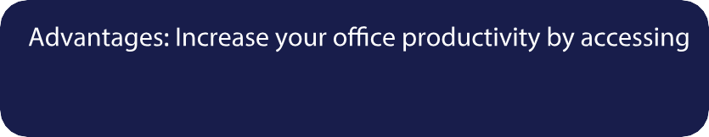

the Corporate LAN from your home, airport, or hotel room, through the public internet over a secure VPN tunnel.

Technical Support and Maintenance

We provide technical support to all the applications that we have been involved in development of. Our technicians
are available to provide 24/7 support and maintenance when so required. We also provide maintenance and support
services to computers, peripherals and Local Area Network. L3 MPLS VPN Design and Implementation
Multiprotocol Label Switching (MPLS) is a mechanism in high-performance telecommunications networks which directs and carries data from one network node to the next. MPLS makes it easy to create "virtual links" between distant nodes. It can encapsulate packets of various network protocols.
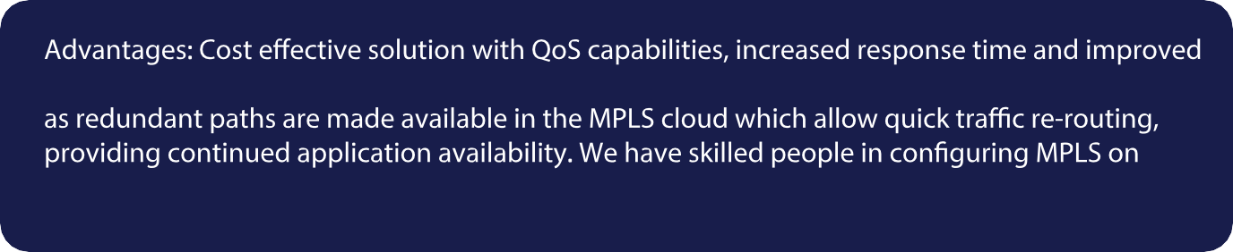
application performance through reduced "hops" between network points, less or no downtime
multi-vendor platforms such as Cisco, Juniper, Mikrotik, and many more







Dedicated Server Design 10
We have experience in designing standard alone application servers for corporate clients, our experience covers the below areas:

- Mail server optimization i.e. security, upgrades, etc.
- DNS deployment, design and recovery on both windows and Linux platform
- Backup Server design and deployment drive results to your business

WHY CHOOSE GIGABYTESMIND TECHNOLOGIES (PTY)LTD?

VALUE FOR MONEY SOLUTIONS
With an industry experience of 6+ years we

to all our clients. We specialize in delivering best solutions at your budget price.

EXCELLENCE

equipped with all the emerging technologies to develop the best software and web solutions for you.

TECHNICAL SUPPORT

project completion to make sure that our clients don’t face any problem even after the development is over.

TURNAROUND TIME
We believe in completing all our projects before deadline to ensure client satisfaction and spare

as per client feedback.


ICT HARDWARE SUPPLY
11

- Computers [Desktop Computers, Notebook Computers, POS Computers, Tablet & Tablet PCs, Workstations]
- Computer Accessories [Computer Components, Notebook Accessories, Keyboards & Keypads, Mice & Trackballs, Computer Speakers etc]
- Printers, Scanners & Print Supplies [Laser Printers, Inkjet & Photo Printers, Ink, Tonner & Print Supplies, Copy Machines & Accessories, Business Inkjet Printers etc]
- Networking Products [Ethernet Switches, Modems, Routers, Wireless Networking, PBX/Multi-User Telephony Systems, Communication Boards, NIC etc]
- Cables [Networking Cables, USB Cables & Hubs, Network Cable Accessories, Audio/Video Cable Products, Parallel &Serial Cables etc]
- Collaboration & IP Telephony [Analogue Phones & Accessories, IP Phones, IP Telephony Accessories, Video Conferencing, IP Servers, IP Software etc]
- Data Storage Products [Hard Drives, Flash Memory, Network Attached Storage (NAS), Media & Accessories, Tape Automation & Drives etc]
- Electronics [Digital Camera & Accessories, Cell/Smart Phones & Accessories, Television & Video Equipment, Photographic Accessories etc]
- Memory [System Memory (RAM), Network Device Memory, Server Memory, Printer Memory, Cache Memory]
- Monitors & Projectors [Projectors, LCD/LED Monitors, Projector Accessories, Interactive Whiteboards & Accessories, Monitor, Display & TV Accessories etc]
Supplies etc]
- Server & Server Management [Servers, Server Accessories & IO Accelerators, Blade Servers, KVM Switches, Consoles & Accessories]
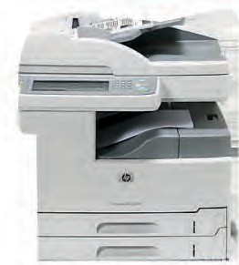
- Power, Cooling & Racks [UPS/Battery Backup Products, Rack Mounting Equipment, Power Adapters, eBatteries etc]
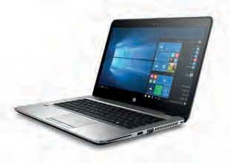
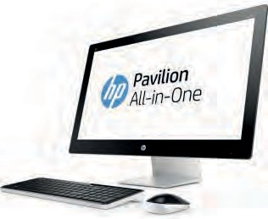
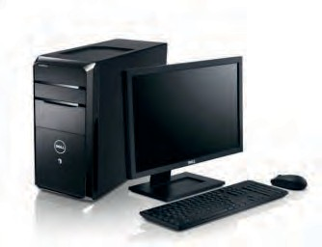

With us you will get best prices and services.





PPE AND GERM/VIRUS PROTECTION 12
Disinfecting Wipes
Premium, industrial grade disinfecting wipes suitable for many industries.
Dispensers
Dispensers that are modern, sleek, and most importantly, functional.
All-In-One Sanitization Solutions
Solutions tailored to meet a number of needs, all in one system.
Soaps, Cleansers & Sanitizers
Roxton’s line of premium soaps, cleansers, and sanitizers.
Disinfectant, Foggers & Sprayers
Foggers, sprayers, and disinfectant solutions to go along with them.
PPE (Personal Protective Equipment)
High-quality, Canadian-made PPE. Masks, face shields, and more.

Antimicrobial Solutions
Protect 90™ antimicrobial protection program makes surfaces easier to clean and protects them.

DIY Wipes

unique product.
uniqu

We pay great care in making sure ordered products are delivered on time.

We take COVID seriously and continuoesly advise everyone to follow suit.


Business Branding

182
of what your customers should expect from you. It’s your voice, your mission, your marketing materials, your packaging, your website. It’s the reason people will choose you over others. Simply put, branding is not just a logo. For small businesses especially, it’s important to attract and retain loyal customers and branding will

- Branding helps you stand out in a saturated market.
If you’re a small business or creative entrepreneur, you may have realized by now that there are a lot of us! It’s
strategy for their brand. There’s no meaning behind their logo and it might not even make sense for their target audience. A good brand has a clear purpose and will help you stand out among other people in your
you because of your brand, your whole package and vibe. First impression is everything.

- Branding gives you credibility.
Having an established and clear brand will make you look like an expert. If you appear to know what you’re talking about and come across as a professional, people will be more likely buy from you.

- With a clear brand, you can charge what you’re worth.
have to take whatever you can get. Many times, you may charge way less than what you deserve just to gain some traction in your business. With a solid brand established, you will come across as a professional and therefore you can charge like one! If you show that you produce high quality work or products, clients will

- Branding leads to customer loyalty.
Good branding elevates a business and builds recognition and loyalty. Customers are attracted to brands that share similar values with them. When you showcase what you value through branding, customers will develop an emotional connection to you. For example, I could go into any Kroger or Target and pick up a regular notebook, planner or calendar, but instead I buy from Appointed because their brand resonates

- Branding leads to returning customers & referrals.
If you deliver what your brand promises, your customers will remember you. Your clients and audience can be the best form of marketing. If they ever need your services or products in the future, they will think of you

- Branding = Consistency.
With solid branding in place, you can easily keep things consistent and make decisions more quickly when it comes to your customer experience. You won’t have to constantly question yourself on the little things like, “What font should I use? What color should I use? How should this look?” With a brand style guide, all of those things will be set.

- Branding helps to attract your ideal clients.
As I said before, people connect with brands that share the same values. If your brand clearly represents business and you want to attract a higher-paying client, your branding needs to be in line.

References

149

Client | Project | Contact
TEC Consultants | Website development and maintenance | Tsietsi Rapahlela 062 034 9646  Tsietsi@tecconsultants.co.za
Bashumi Water Services | Hosting Services and maintenance | Samuel Baloyi 081 824 1291  Info@bashumi.co.za
Tera Zama Solutions | Website development and App development | Thembikhaya 078 673 9530  info@terazama.co.za
Brilliant Minds Academy | Computer Lab architecture and networking | Prudence Maisela 076 789 0064
Ntsako E Trading Entreprises | Business Branding | Ntsako 076 038 6364
Bukutela Trading Projects | Business Branding | Eddie  076 265 9869/ 078 392 3312
Q & R Home Assistance | Business Branding | Redwaan Botha 0812564249 / 0685853665

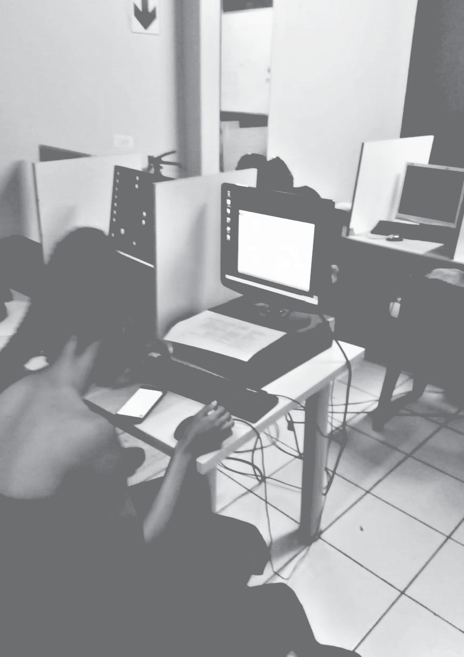



Gigabytesmind Technologies

Contact us
(087) 510 0887 / (076) 358 8861
15 Von Willigh St. Club View info@gigabytesmind.co.za www.gigabytesmind.co.za



